**DATE**:

**TASK2: 2D-PLOT(MATPLOTLIB)**

**Aim:** Program to create a 2D-plot and line plot using Matlplotlib Library.

**Data set:** Iris data set

**Source:** UCI Repository

**MATPLOTLIB:**

Matplotlib is a Python 2D plotting library which produces publication quality figures in a variety of hardcopy formats and interactive environments across platforms. Matplotlib can be used in Python scripts, the Python and  shells, the [Jupyter](http://jupyter.org/) notebook, web application servers, and four graphical user interface toolkits.

**Program:**

In [3]:



**import** pandas **as** pd

**import** matplotlib.pyplot **as** plt

data**=**{'d1':[10,11,12,13],'d2':[20,21,22,23]}

print(data)

{'d1': [10, 11, 12, 13], 'd2': [20, 21, 22, 23]}

In [4]:



plt.plot(data["d1"],data["d2"])

Out[4]:

[<matplotlib.lines.Line2D at 0x1300e0f0dd8>]

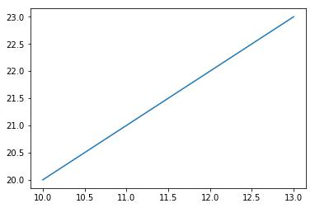

In [5]:



plt.scatter(data["d1"],data["d2"])

Out[5]:

<matplotlib.collections.PathCollection at 0x1302102fcf8>

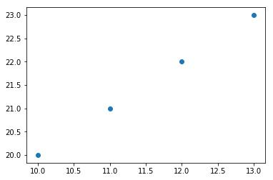

In [6]:

data1**=**pd.DataFrame(data)

print(data1)

d1 d2

0 10 20

1 11 21

2 12 22

3 13 23

In [7]:



plt.bar(["d1"],data["d2"])

Out[7]:

<BarContainer object of 4 artists>

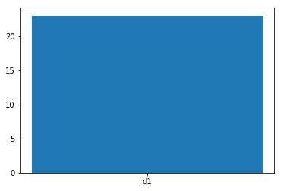

**RESULT:** The above program matplotlib executed successfully.